

International Islamic University Chittagong

Project Report of “Trust Bank”

**Course code: CSE – 1222**

**Course Title: “Computer Programming 2 Lab”**

**Submission Date: 21st May, 2023**

**Submitted by:**

**Name: Md Anayet Ullah**

**Matric ID: C223133**

**Section: 2DM**

**2nd semester**

**Name: Mainur Rahat**

**Matric ID: C223147**

**Section: 2DM**

**2nd semester**

**Submitted to :**

**Name: Md Shahriar Younus Ashik**

**Adj.Faculty, Department of CSE, IIUC**

About “Trust Bank”:

Trust Bank App is a project made by QT .This app helps you know about the information of the Trust Bank. A user can use this app at anywhere he wants. This app provides you to some basic tools for use. When a user visit this app he will be shown the welcome page. Then use this app, first thing to do create an account .To create an account , the user has to entry the required information’s such as name , email ,phone number and password. After creation of account the user will be shown in log in page. After the successfully log in, he/she finds the menu page and can use some features like deposit, withdraw, paying utility bill, take loan etc. Trust Bank only stores the information given by the users while creating account in SQL.

Features:

1. Deposit Money.

2. Withdraw Money.

3. Pay Utility Bill.

4. Take Loan.

5. Fixed Deposit.

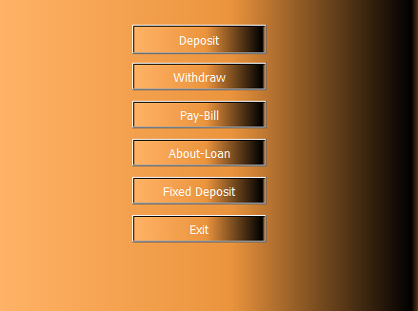

Tool Used:

1. C++

2. QT

3. SQL

REGISTER PAGE: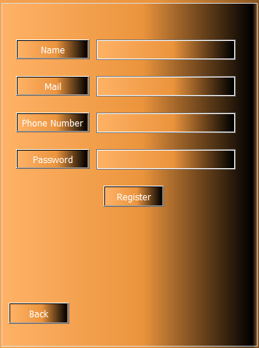

A new user can create an account to use this page. To an account some information is needed. When a user gives Name, Email, Phone number and password then a new account has created.

LOG IN PAGE:

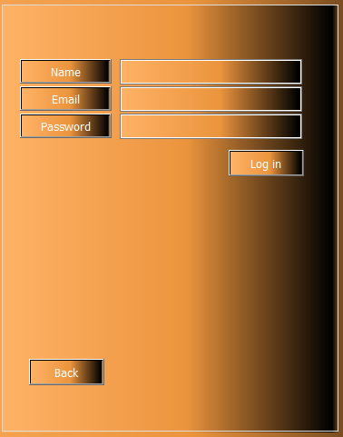

After successful registration, a user can log in and use the main feature of this app. For log in this app some information is need like Name, Email and password that he/she was gave in the registration.

DEPOSIT MONEY AND WITHDRAW

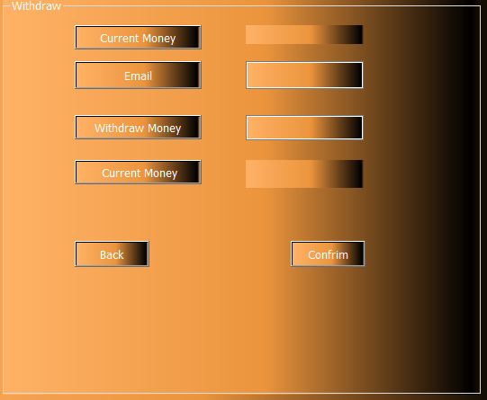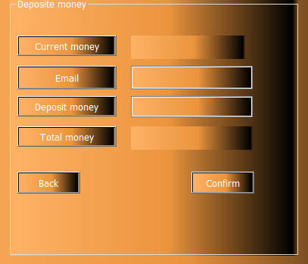

A user can deposit money and withdraw money at any time. To use this feature user must have unique account. User can also have some extra feature like take loan, fixed deposit and pay your utility bill. Picture are given below:

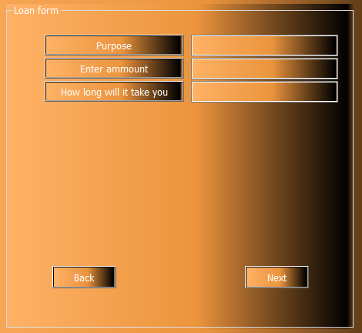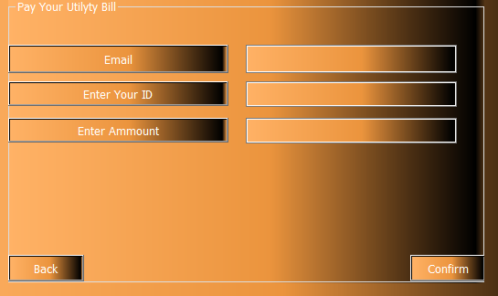

If you want to know about the bank details, vacation, recruitment, holidays, you will use the menu. Picture are given below:

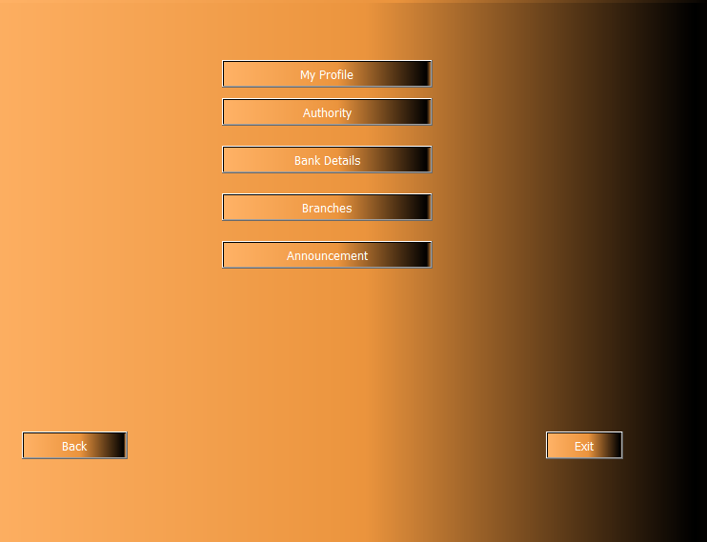

https://github.com/Anayet6866/Bank-Management-System.

https://youtu.be/iHAEqfACOrQ

Thank You.